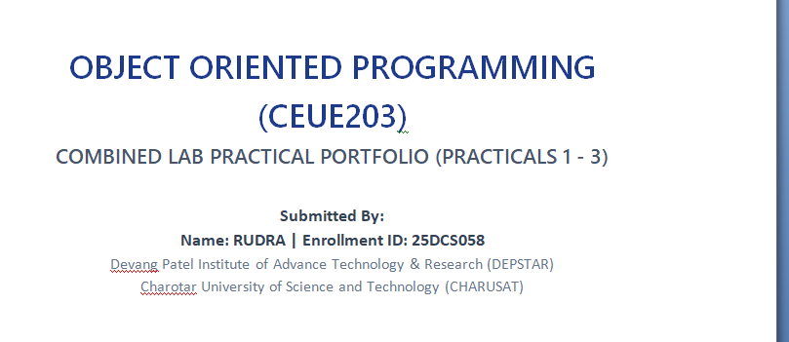 | 

WEB DEVELOPMENT FRAMEWORKS
(ITUE203)
COMBINED LAB PRACTICAL PORTFOLIO (PRACTICALS 1 - 2)
- SITE SITEMAP & WIREFRAMES -
Submitted By:
Name: RUDRA | Enrollment ID: 25DCS058
Devang Patel Institute of Advance Technology & Research (DEPSTAR)
Charotar University of Science and Technology (CHARUSAT)

1. Visual Site Sitemap Diagram
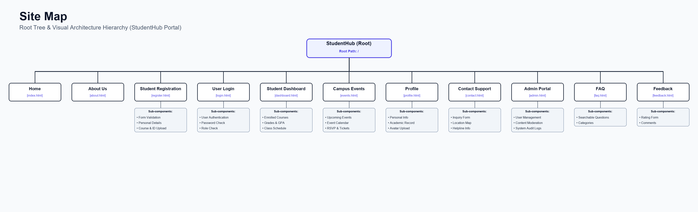
Figure: Site Sitemap Hierarchy Diagram

2. Individual Page Wireframes

Wireframe - Home Page (index.html)
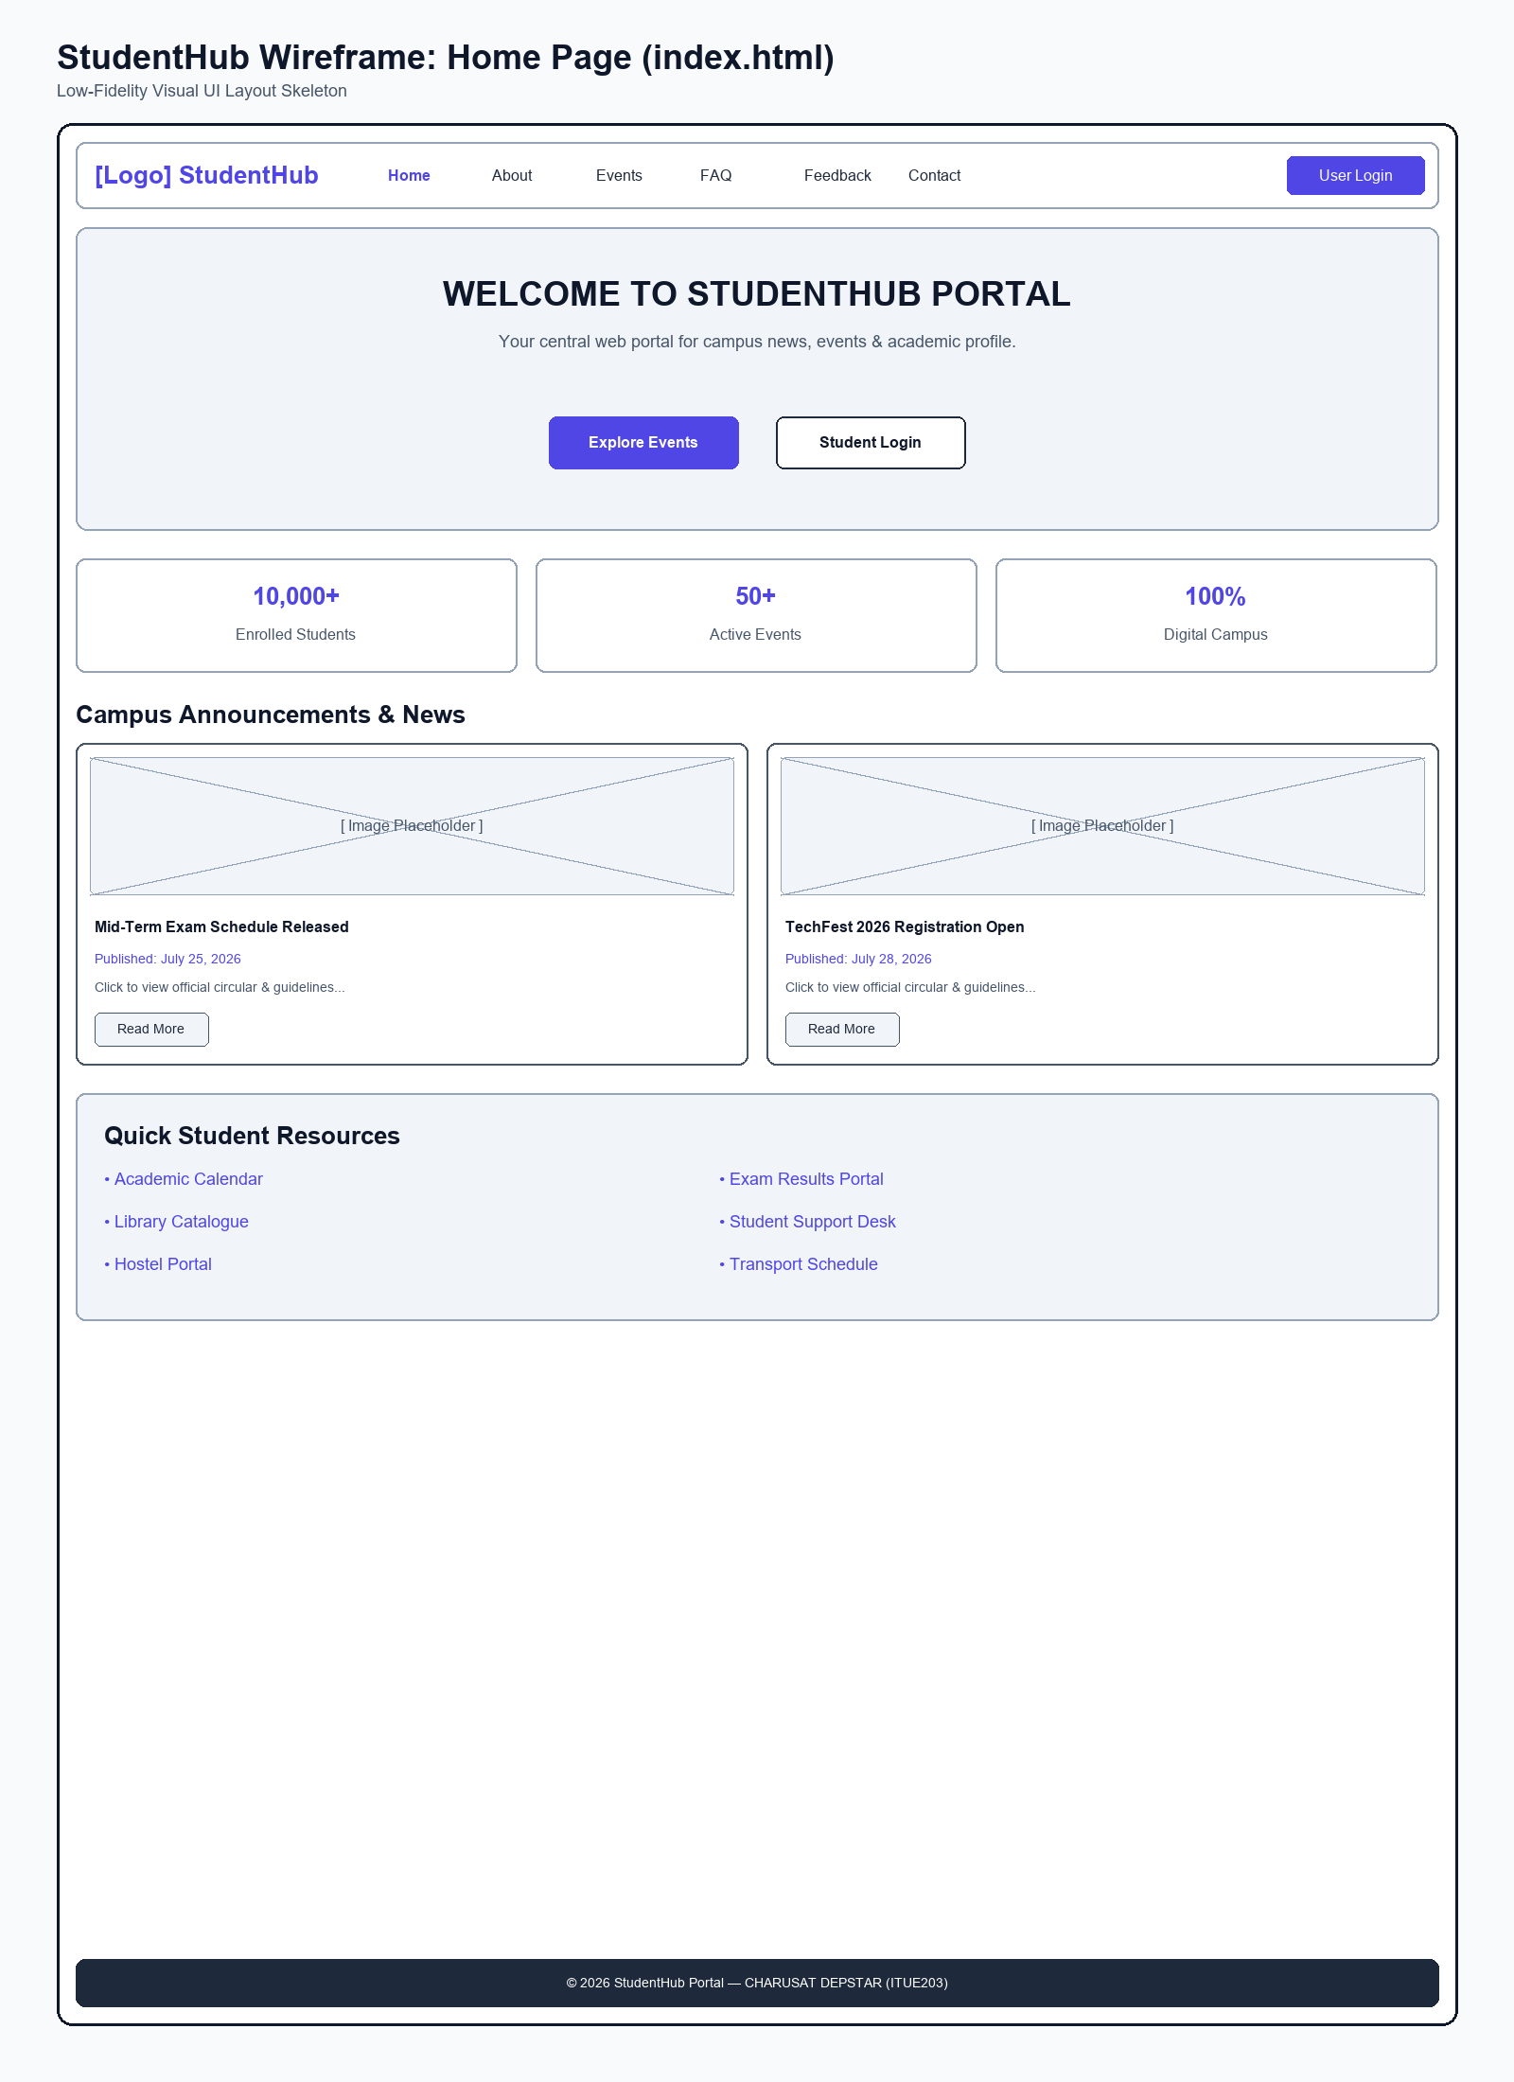
Figure: Low-Fidelity Wireframe Blueprint for Home Page

Wireframe - About Us Page (about.html)
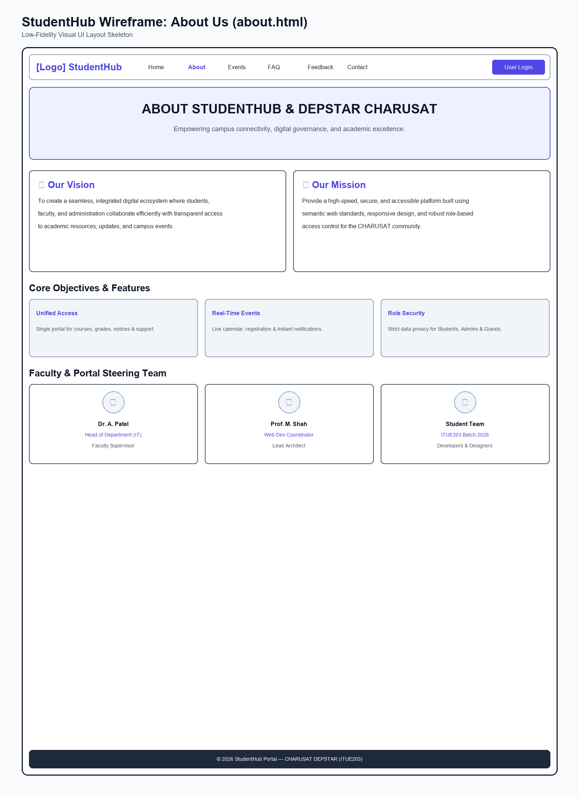
Figure: Low-Fidelity Wireframe Blueprint for About Us Page

Wireframe - Student Registration Page (register.html)
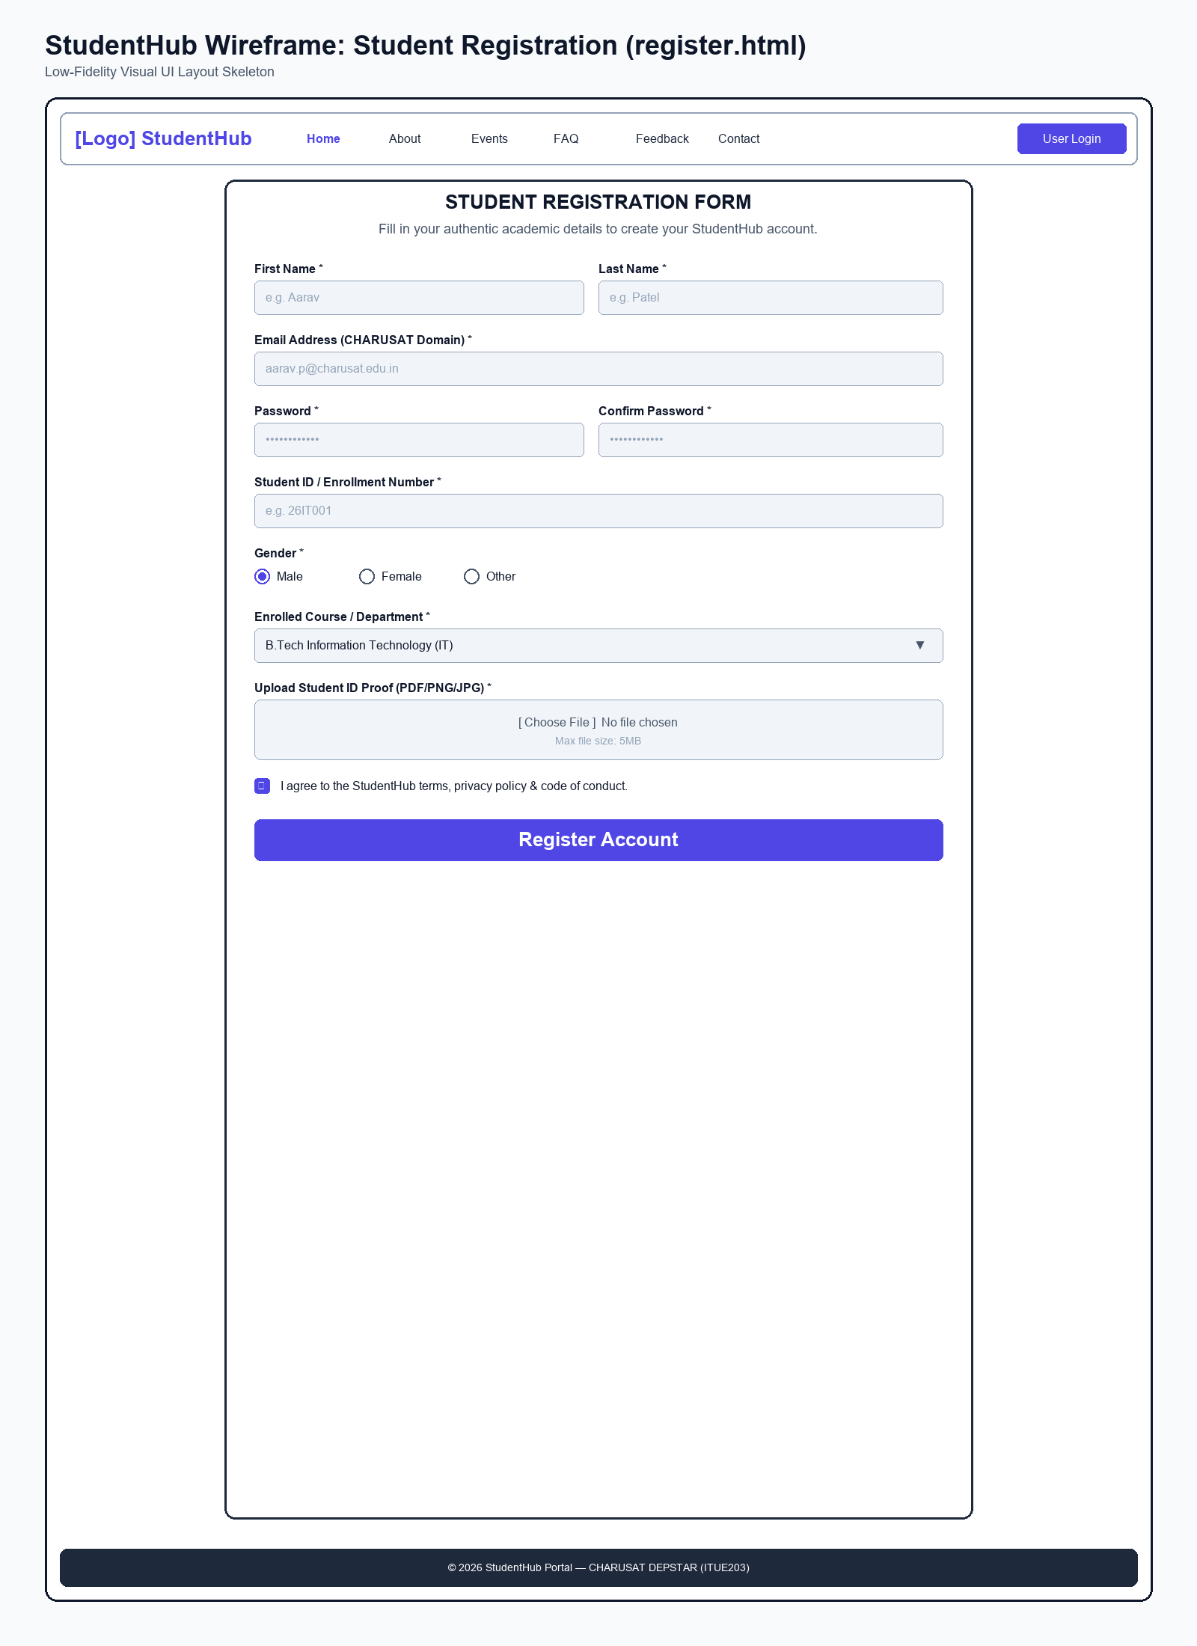
Figure: Low-Fidelity Wireframe Blueprint for Student Registration Page

Wireframe - User Login Page (login.html)
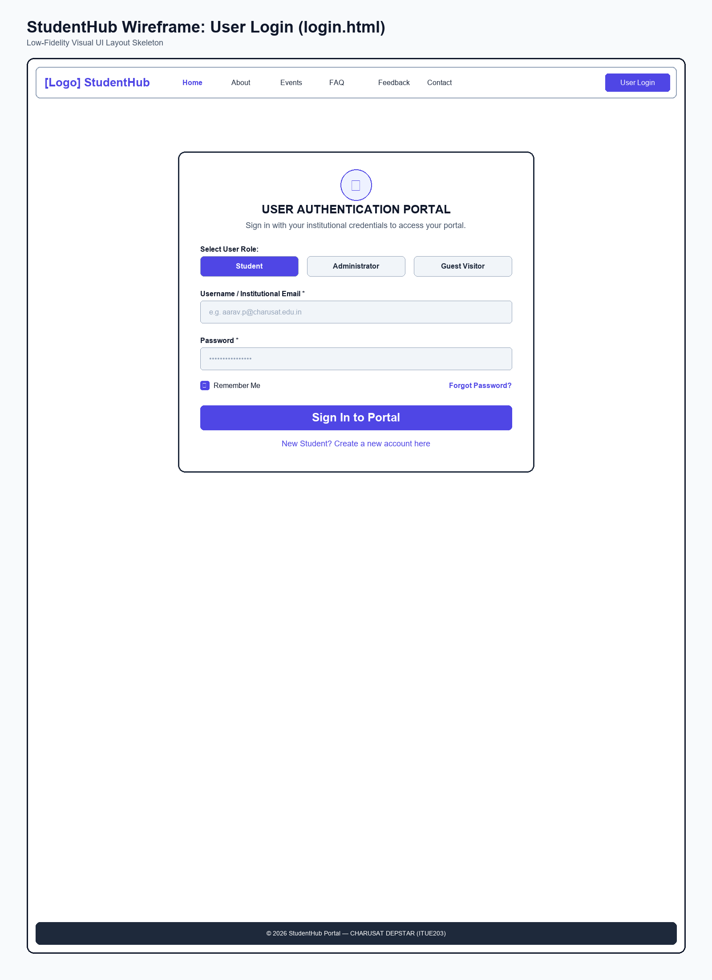
Figure: Low-Fidelity Wireframe Blueprint for User Login Page

Wireframe - Student Dashboard Page (dashboard.html)
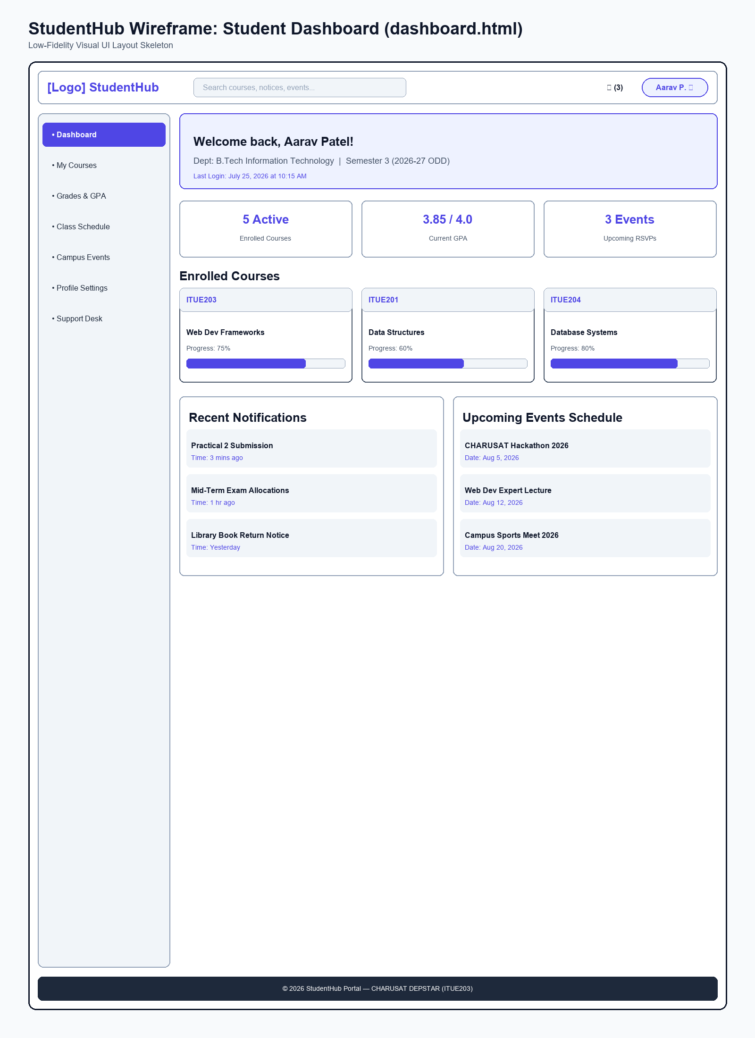
Figure: Low-Fidelity Wireframe Blueprint for Student Dashboard Page

Wireframe - Campus Events Page (events.html)
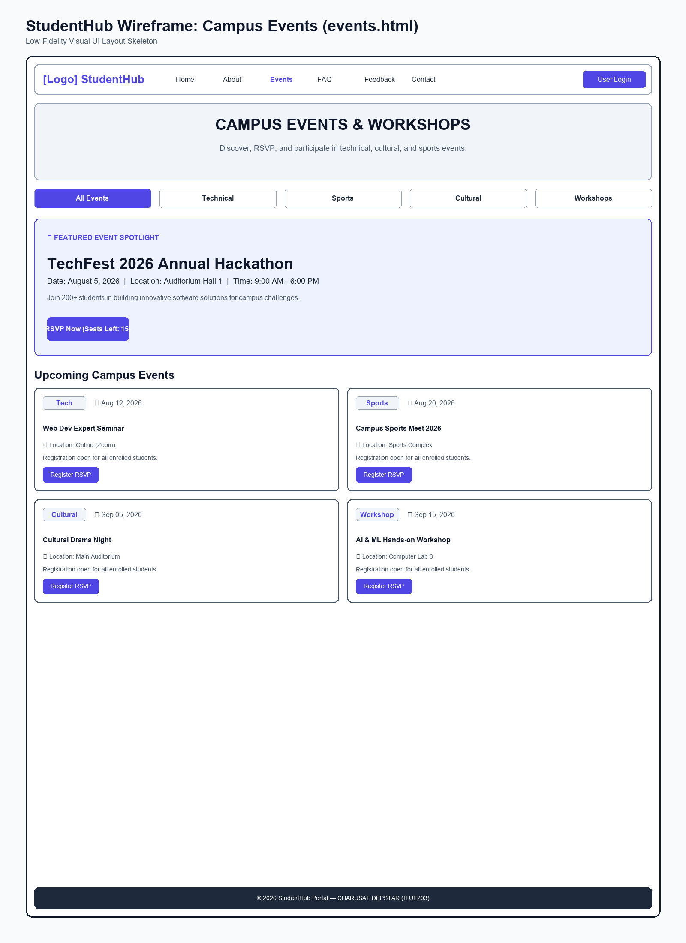
Figure: Low-Fidelity Wireframe Blueprint for Campus Events Page

Wireframe - Student Profile Page (profile.html)
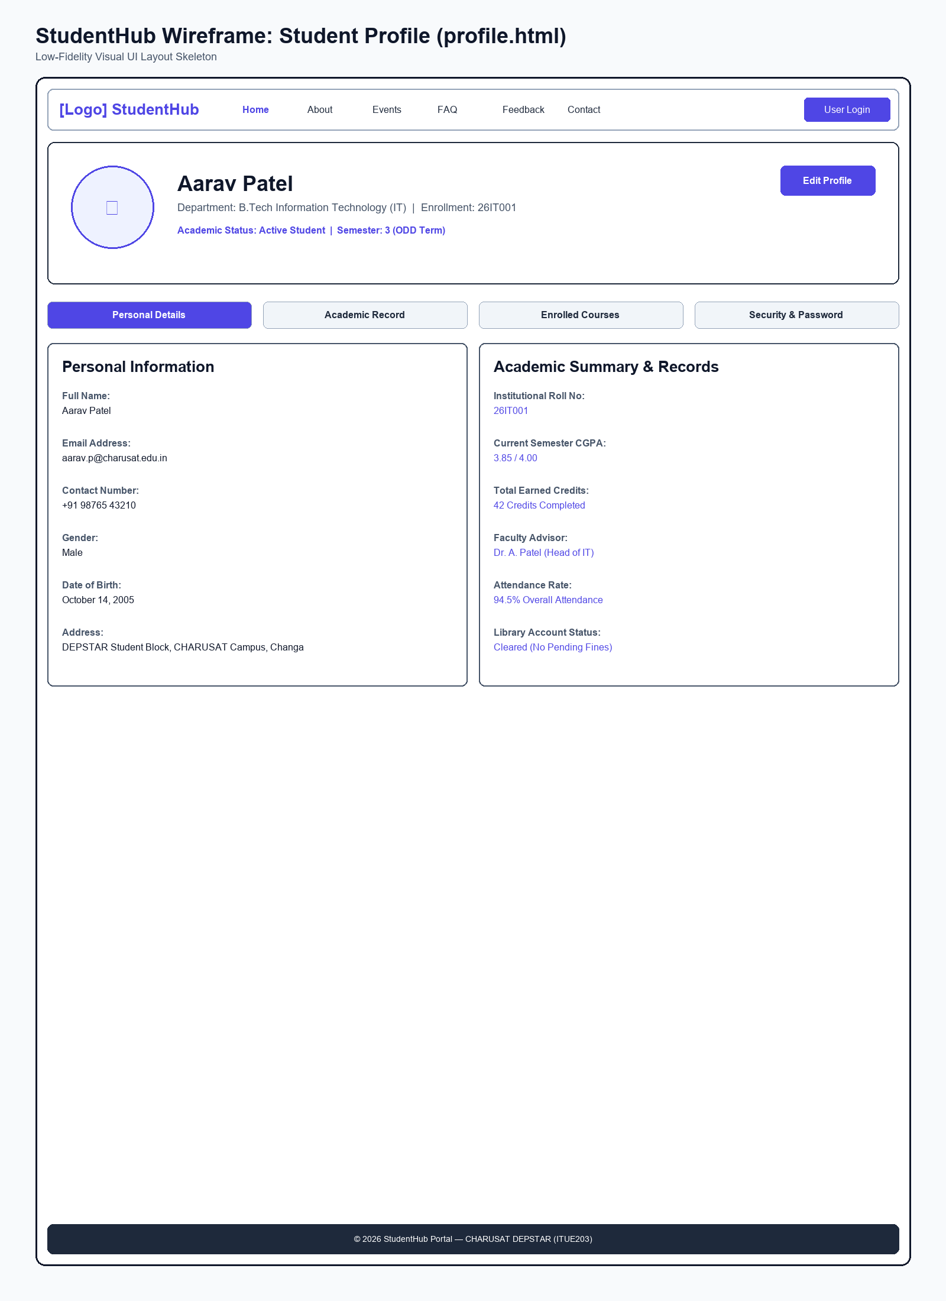
Figure: Low-Fidelity Wireframe Blueprint for Student Profile Page

Wireframe - Contact Support Page (contact.html)
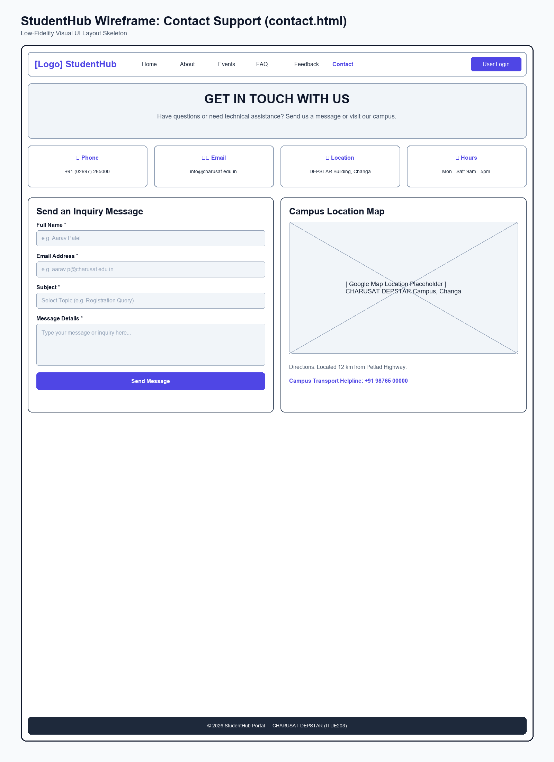
Figure: Low-Fidelity Wireframe Blueprint for Contact Support Page

Wireframe - Admin Portal Page (admin.html)
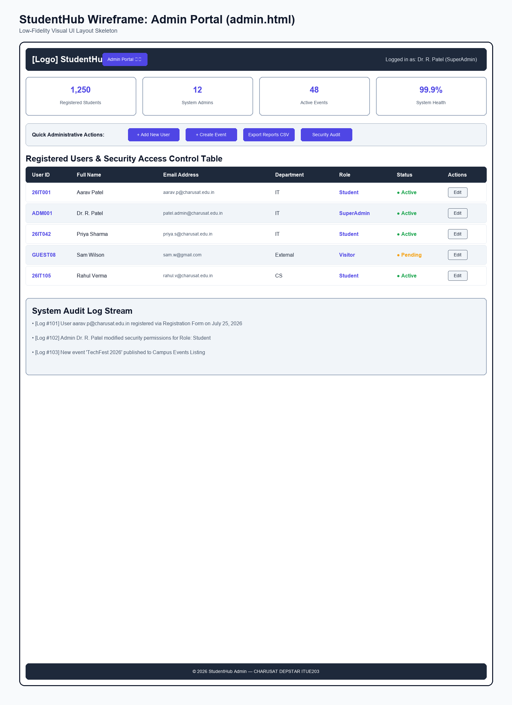
Figure: Low-Fidelity Wireframe Blueprint for Admin Portal Page

Wireframe - FAQ Page (faq.html)
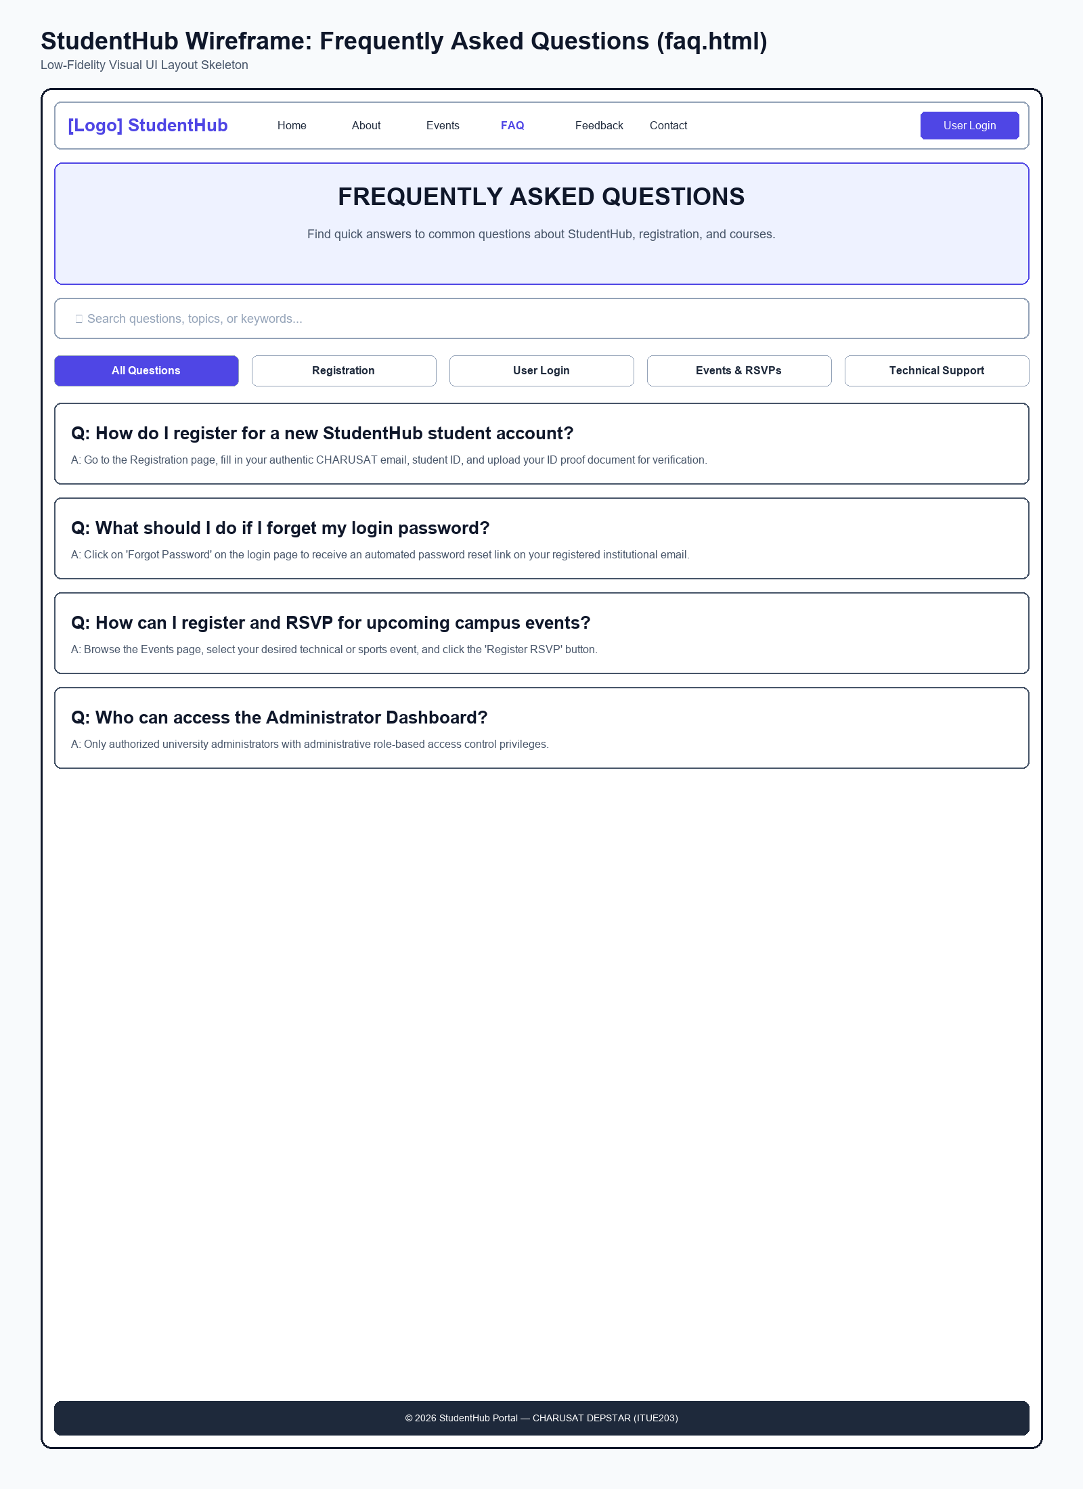
Figure: Low-Fidelity Wireframe Blueprint for FAQ Page

Wireframe - Feedback Survey Page (feedback.html)
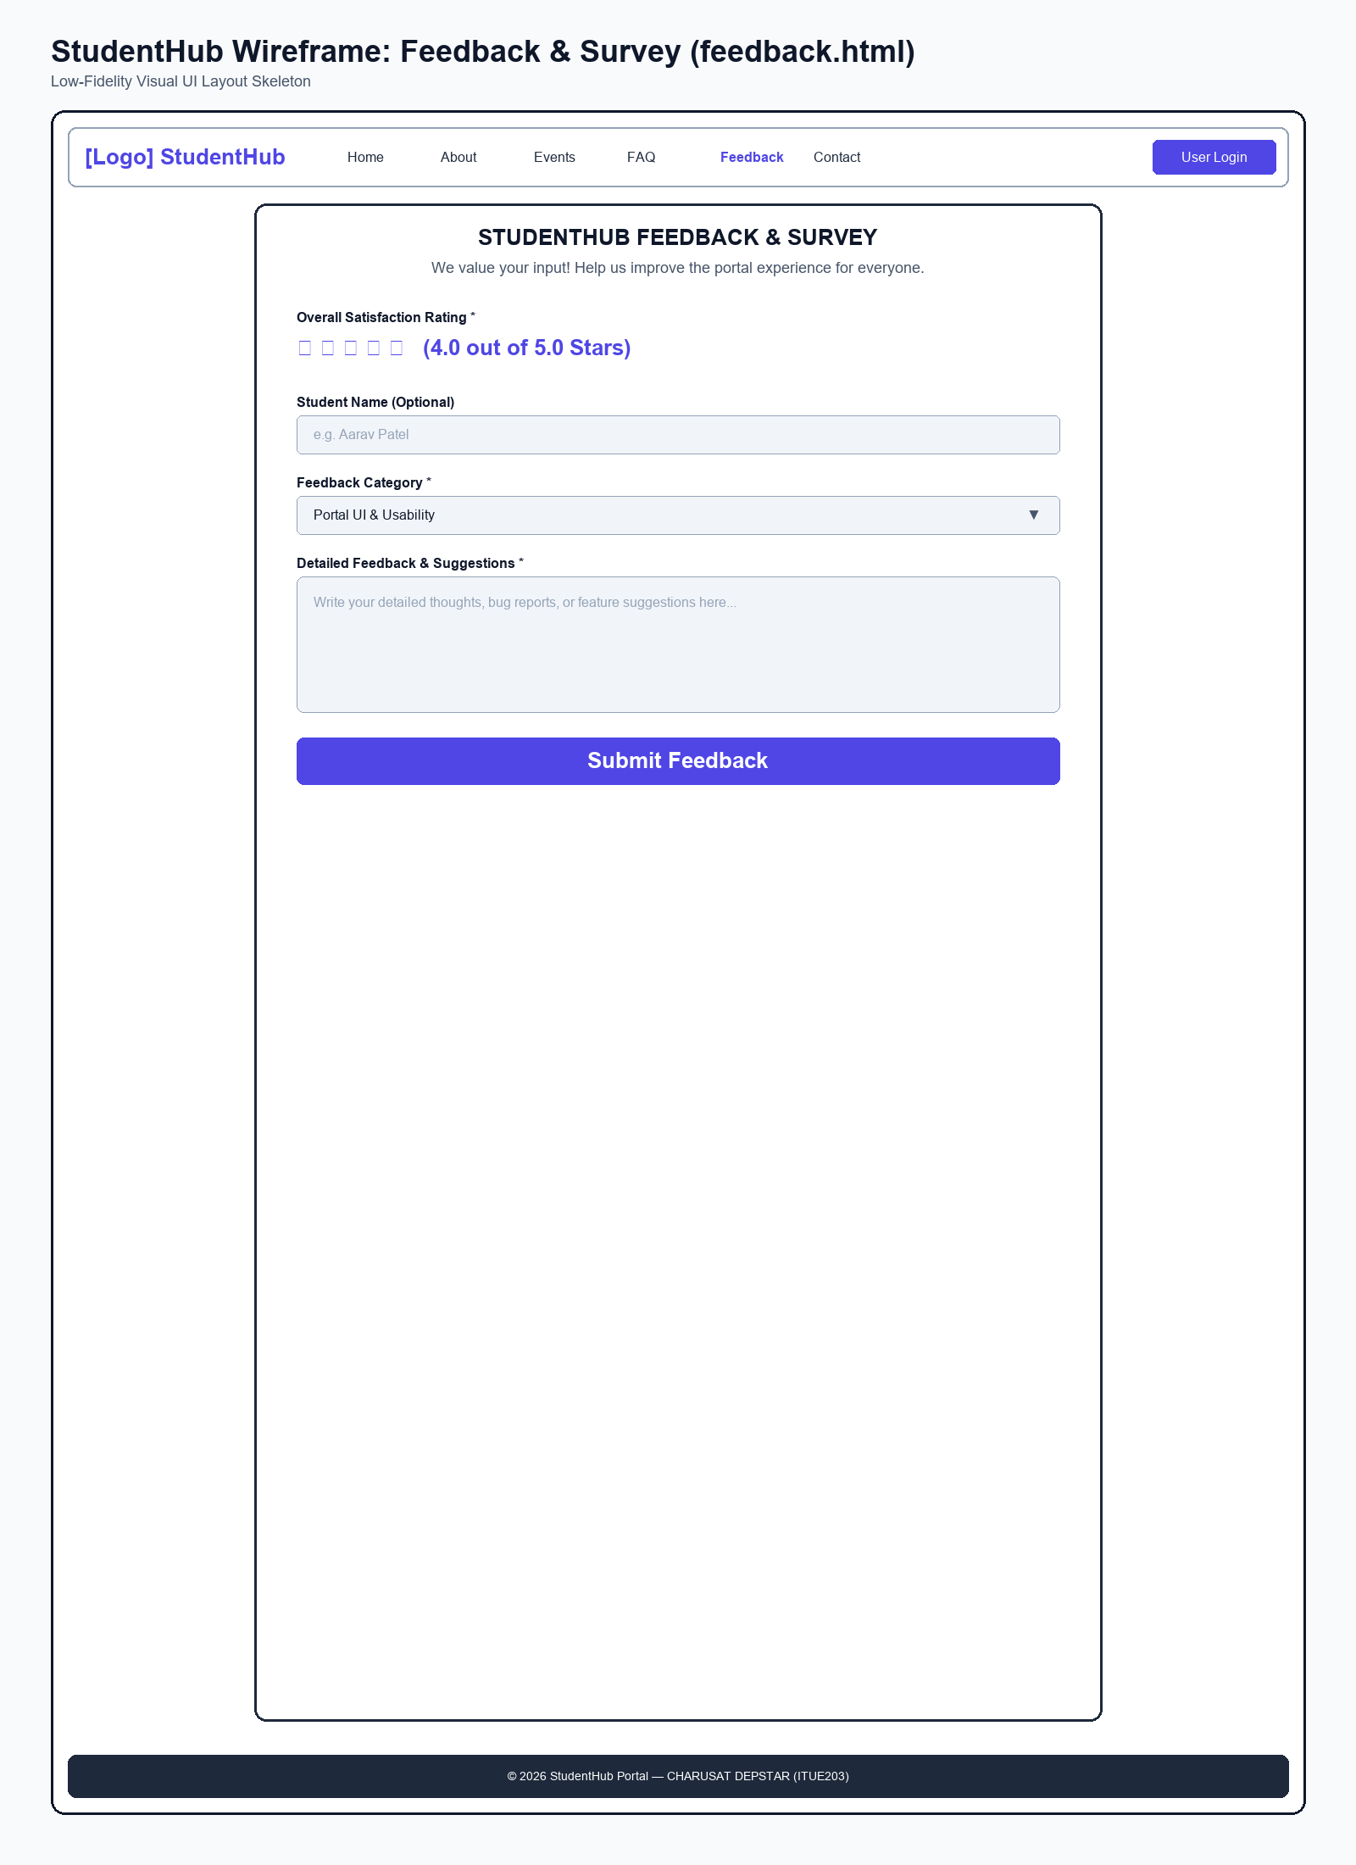
Figure: Low-Fidelity Wireframe Blueprint for Feedback Survey Page

